

JAVA PROJECT REPORT ON
PERSONAL CONTACT DIRECTORY WITH SEARCH AND UPDATE FEATURES

Submitted by
SAMVARDHINI K
25BIT142

Under the Guidance of
MUGILAN R

Technical Trainer
Technical Department, KG College of Arts and Science

Academic Year: 2025 – 2026
APRIL 2026
Semester: II

DECLARATION
I hereby declare that the project entitled “PERSONAL CONTACT DIRECTORY WITH SEARCH AND UPDATE FEATURES” submitted in partial fulfillment of the requirements for the course Java Programming is a record of my original work carried out under the guidance of MUGILAN R,Technical Trainer, Technical Department, KG College of Arts and Science.
I further declare that this project has not been submitted previously, either in part or in full, for the award of any degree, diploma, or other similar title, at this or any other institution.
I have acknowledged all sources of information used in this project wherever applicable.

April 2026
Coimbatore

________________________
(SAMVARDHINI K)

CERTIFICATE
This is to certify that the project entitled “PERSONAL CONTACT DIRECTORY WITH SEARCH AND UPDATE FEATURES” is a bona fide work carried out by SAMVARDHINI K, B.Sc IT ‘B’(2025-2028) INFORMATION TECHNOLOGY, KG College of Arts&Science, in partial fulfillment of the requirements for the course Java Programming.
This project has been completed under my supervision and guidance during the academic period April 2026.

Place: Coimbatore.
Date:

Submitted for the Viva-Voce Examination held on

__________________________________

Guide: Head of the Department
(Technical Trainer, KGCAS) (Technical Head, KGCAS)
______________________ ______________________

TABLE OF CONTENTS
S. No. | Topics | Page. No.
1 | Introduction
1.1 | Objective
1.2 | Overview
1.3 | Features
2 | Program Analysis
2.1 | Problem Definition
2.2 | Project Overview
2.3 | Scopes and Limitations
3 | System Design
3.1 | Modules
4 | Methodology
4.1 | Problem Analysis
4.2 | System Design
4.3 | Program Development
4.4 | Testing and Validation
4.5 | Result and Documentation
4.6 | Algorithm
4.7 | Flowchart
5 | Source Code
6 | Input and Output Screens
7 | Discussion and Conclusion
7.1 | Discussion
7.2 | Conclusion
8 | References

ABSTRACT
The Personal Contact Directory with Search and Update Features is a Java-based application designed to help users store and manage their personal contact information in an organized manner. In many situations, people maintain contact details manually in notebooks or scattered digital notes, which can lead to difficulty in finding specific contacts, outdated information, and poor record management. This project aims to provide a simple and efficient system for storing, searching, and updating contact details in a structured format.
The system allows users to add contact information such as name, phone number, email address, and other relevant details. It also provides a search feature that helps users quickly find a contact by entering the name or phone number. Additionally, the update feature enables users to modify existing contact details whenever changes occur, ensuring that the information remains accurate and up to date.
The application is developed using Core Java programming concepts, including classes, objects, arrays, methods, loops, and conditional statements. The program can be implemented as a console-based application or enhanced with a graphical user interface using Java Swing.
The main objective of this system is to improve contact management, provide quick access to stored information, and reduce the effort required to maintain personal directories manually. This project demonstrates the practical use of programming concepts in Java and provides a basic foundation for building more advanced contact management systems in the future.

- INTRODUCTION
In today’s digital world, managing personal contacts efficiently has become very important. Many people still store contact details such as phone numbers, addresses, and email IDs manually in notebooks or simple phone lists. However, manual contact management can lead to several issues such as difficulty in searching contacts, updating information, or maintaining organized records. With the help of computer technology, digital contact management systems can simplify the process of storing, searching, and updating personal contacts. A computerized contact directory allows users to maintain a structured list of contacts and perform operations such as adding, searching, updating, and deleting contact information easily. The Personal Contact Directory with Search and Update Features is a Java-based application designed to store and manage contact details efficiently. The system allows users to add new contacts, search for existing contacts using names or phone numbers, and update contact details whenever required.
This application provides a simple and organized way to maintain contact information such as name, phone number, email address, and address. The program helps users quickly access stored contact details without searching manually through large lists.
The project is developed using Core Java programming concepts such as classes, objects, arrays, methods, loops, and conditional statements. The system can be implemented either as a console-based application or with a graphical user interface using Java Swing.
The main objective of this system is to provide a simple and efficient way to manage personal contacts digitally while demonstrating the practical use of Java programming concepts in developing real-world applications.
1.1 Objective
The main objective of the Personal Contact Directory with Search and Update Features is to develop a simple Java-based application that allows users to manage personal contact details efficiently.
The specific objectives of this project are:
• To design and develop a Java-based contact directory system.
• To store personal contact details such as name, phone number, email, and address.
• To allow users to search for contacts quickly.
• To allow users to update contact information easily.
• To reduce the difficulty of managing contacts manually.
• To demonstrate the use of Core Java concepts such as arrays, loops, classes, and methods.
1.2 Overview
The Personal Contact Directory with Search and Update Features is a menu-driven application developed using the Java programming language. The system allows users to store and manage personal contact information efficiently.
The application allows users to perform operations such as:
• Adding new contact details
• Searching for contacts by name or phone number
• Updating existing contact information
• Displaying all stored contacts
The system maintains a structured list of contacts that can be easily accessed and modified. Users can quickly find a contact without manually checking multiple records.
This project demonstrates how Java programming can be used to develop simple information management systems that can be useful in daily life.
1.3 Features
The Personal Contact Directory System includes the following features:
• Add Contact – Allows the user to add new contact details such as name, phone number, email, and address.
• Search Contact – Enables users to search for contacts using the name or phone number.
• Update Contact – Allows modification of existing contact details.
• Display Contacts – Shows the list of all saved contacts.
• User-Friendly Interface – Provides a simple menu-driven system for easy use.
• Fast Contact Retrieval – Quickly finds contact information without manual searching.

- PROGRAM ANALYSIS

Program analysis is an important phase in software development where the problem is studied carefully and the requirements of the system are identified.
This phase helps in understanding how the system should function and what features are needed to solve the problem effectively. The analysis stage focuses on identifying problems in the existing system and developing a computerized solution that improves efficiency and organization.
2.1 Problem Definition
Many people still maintain personal contact information manually using notebooks or unorganized digital lists.
This manual system creates several problems such as:
• Difficulty in searching for specific contacts
• Difficulty in updating contact information
• Risk of losing important contact details
• Lack of organized storage for contact records
• Time-consuming process to find specific information
To overcome these problems, a computerized contact directory system is required.
The Personal Contact Directory with Search and Update Features provides a digital solution where users can easily store, search, and update contact information.
2.2 Project Overview
The Personal Contact Directory System is a Java-based application developed to help users manage personal contact information effectively.
The system provides a menu-driven interface where users can perform various operations on stored contacts.
The main functionalities include:
• Adding new contact details
• Searching contacts by name
• Updating existing contact information
• Displaying stored contacts
This project is implemented using Core Java programming concepts and can be developed as a console-based or graphical application.
2.3 Scopes and Limitations
Scope
The scope of the Personal Contact Directory System includes:
• Storing personal contact details
• Searching contacts quickly
• Updating contact information
• Displaying stored contacts
• Demonstrating Java programming concepts
The system can be used for:
• Personal contact management
• Student contact directories
• Small office contact records
• Simple address book applications
Limitations:
• The system stores contacts only during program execution (if no database is used).
• Limited number of contacts can be stored depending on the program structure.
• Advanced features such as cloud storage or synchronization are not included.

- SYSTEM DESIGN
System design is the phase where the structure and components of the system are planned before coding begins. The Personal Contact Directory System is designed as a menu-driven application where users can perform operations such as adding, searching, updating, and displaying contacts. The system is divided into different modules to handle specific tasks.
3.1 Modules
1. Add Contact Module
This module allows users to add new contact information.
The details stored include:
• Name
• Phone Number
• Email Address
• Address
The entered information is stored in the contact directory.
2. Search Contact Module
This module allows users to search for a contact using the name or phone number.
Functions include:
• Accepting search input from the user
• Checking stored contacts
• Displaying matching contact details
3. Update Contact Module
This module allows users to modify existing contact information.
Users can update:
• Phone number
• Email address
• Address
This feature helps keep contact information up to date.
4. Display Contacts Module
This module displays all stored contacts in an organized format.
Example Output:
Name: Arun Kumar
Phone: 9876543210
Email: arun@gmail.com
Address: Chennai
5. Exit Module
This module allows the user to exit the application safely.

- METHODOLOGY
Methodology explains the process followed to develop the project.
The development process includes the following stages:
• Problem Analysis
• System Design
• Program Development
• Testing and Validation
• Result and Documentation
4.1. Problem Analysis
In this phase, the need for a digital contact management system was studied.
The main problems identified were:
• Difficulty in managing contacts manually
• Time-consuming search process
• Difficulty updating contact information
Based on these problems, the system requirements were defined.
4.2. System Design
In this stage, the system structure was designed.
The application includes the following modules:
• Add Contact
• Search Contact
• Update Contact
• Display Contacts
• Exit System
4.3. Program Development
The program was developed using the Java programming language.
During development, the following steps were followed:
• Creating classes and methods
• Writing code to store contact details
• Implementing search and update features
• Designing a menu-driven interface
4.4. Testing and Validation
Testing ensures that the system works correctly.
Example Test Cases:
Test Case | Expected Result
Add Contact | Contact stored successfully
Search Contact | Correct contact displayed
Update Contact | Correct total displayed
Display Contacts | Contact updated correctly
All contacts shown properly.
4.5. Result and Documentation
After testing, the results were documented. The system successfully performs operations such as adding, searching, and updating contacts.Screenshots of program execution can be included to demonstrate the system functionality.
4.6. Algorithm
Algorithm for the Personal Contact Directory System:
1.Start the program
2.Display the menu options
3.Select an option (Add/Search/Update/Display)
4.If Add Contact → Enter contact details
5.If Search Contact → Enter name or phone number
6.If Update Contact → Modify existing details
7.If Display Contacts → Show all stored contacts
8.Repeat until user selects Exit
9.End the program
4.7. Flowchart
Students should draw a flowchart showing the program flow.
Example flow:
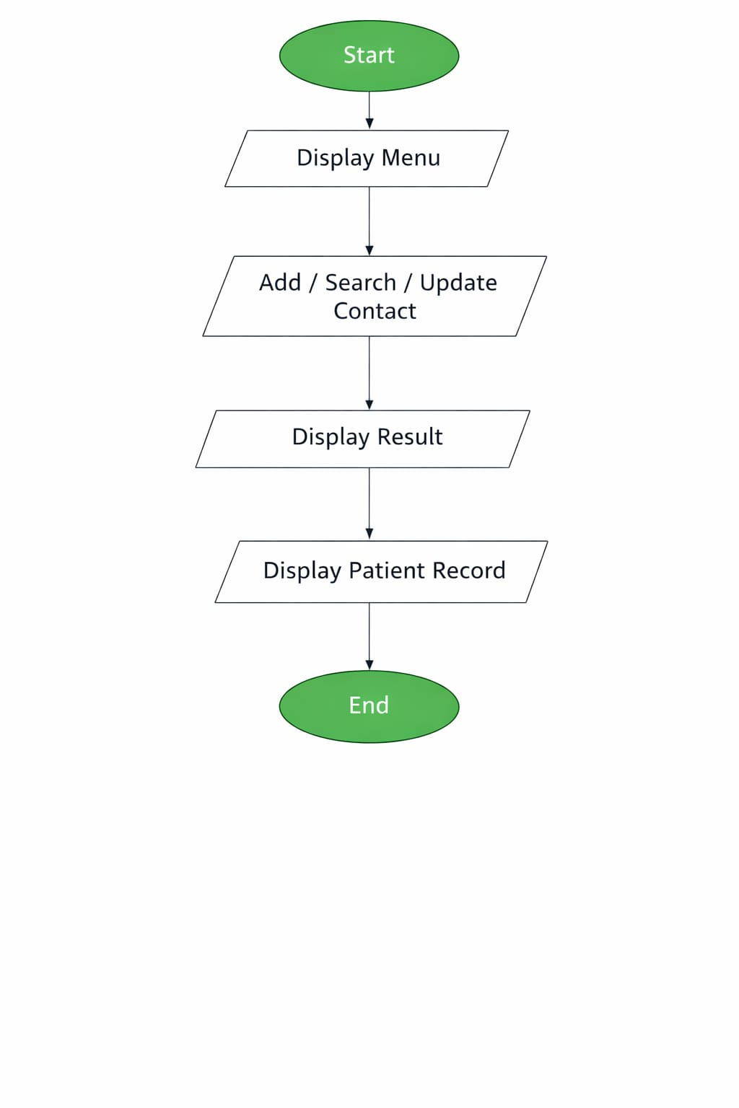
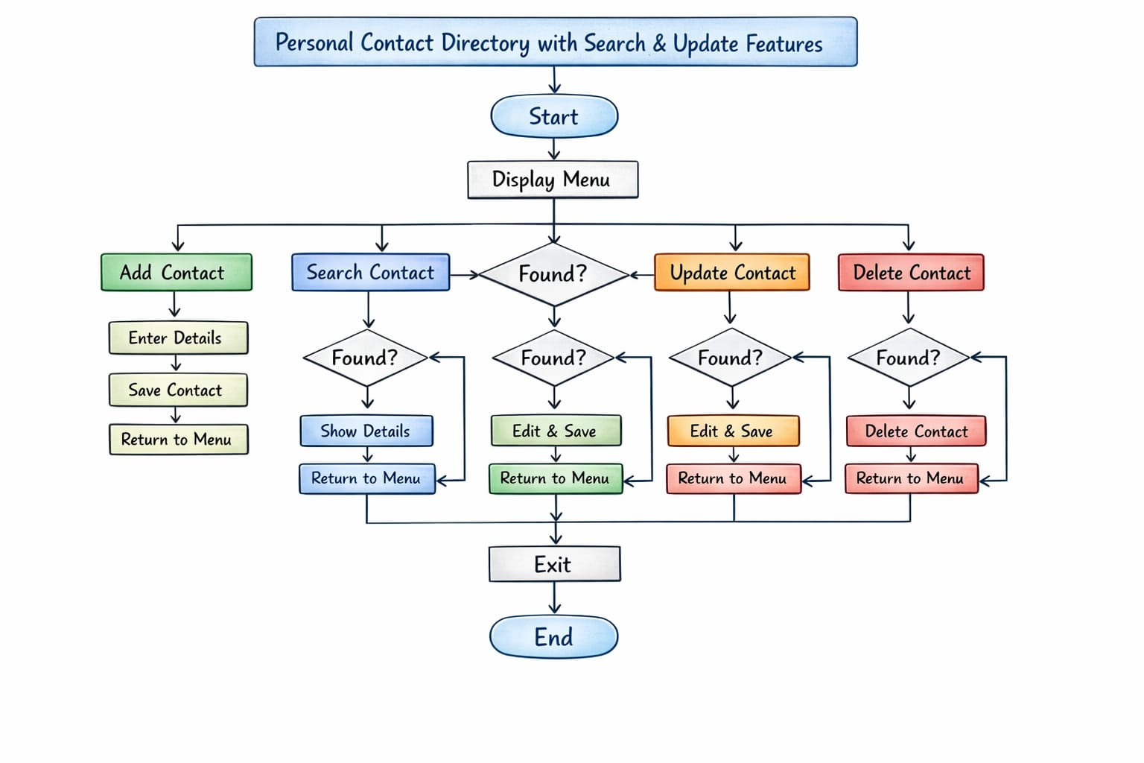

- SOURCE CODE
import java.util.Scanner;

class Contact {
String name;
String phone;

String email;
String address;
}

public class PersonalContactDirectory {

static Contact contacts[] = new Contact[100];
static int count = 0;

public static void addContact(Scanner sc) {
if (count>= 100) {
System.out.println("Contact directory is full!");
return;
}

Contact c = new Contact();

System.out.print("Enter Name:");
c.name = sc.nextLine();

System.out.print("Enter Phone Number:");
c.phone = sc.nextLine();

System.out.print("Enter Email:");
c.email = sc.nextLine();

System.out.print("Enter Address:");
c.address = sc.nextLine();

contacts[count] = c;
count++;

System.out.println("Contact added successfully!");
}

public static void displayContacts() {
if (count == 0) {
System.out.println("No contacts available.");
return;
}

System.out.println("\n---- Contact List ----");
for (int i = 0; i<count; i++) {
System.out.println("Contact"+ (i + 1));
System.out.println("Name:"+ contacts[i].name);
System.out.println("Phone:"+ contacts[i].phone);
System.out.println("Email:"+ contacts[i].email);
System.out.println("Address:"+ contacts[i].address);
System.out.println("----------------------");
}
}

public static void searchContact(Scanner sc) {
System.out.print("Enter name to search:");
String searchName = sc.nextLine();

boolean found = false;

for (int i = 0; i<count; i++) {
if (contacts[i].name.equalsIgnoreCase(searchName)) {
System.out.println("Contact Found!");
System.out.println("Name:"+ contacts[i].name);
System.out.println("Phone:"+ contacts[i].phone);
System.out.println("Email:"+ contacts[i].email);
System.out.println("Address:"+ contacts[i].address);
found = true;
break;
}
}

if (!found) {
System.out.println("Contact not found.");
}
}

public static void updateContact(Scanner sc) {
System.out.print("Enter name of contact to update:");
String name = sc.nextLine();

for (int i = 0; i<count; i++) {
if (contacts[i].name.equalsIgnoreCase(name)) {

System.out.print("Enter new phonenumber:");
contacts[i].phone = sc.nextLine();
System.out.print("Enter new email:");
contacts[i].email = sc.nextLine();

System.out.print("Enter new address:");
contacts[i].address = sc.nextLine();

System.out.println("Contact updated successfully!");
return;
}
}

System.out.println("Contact not found.");
}

public static void main(String[] args) {

Scanner sc = new Scanner(System.in);
int choice;

do {
System.out.println("\n===== Personal Contact Directory =====");
System.out.println("1. Add Contact");
System.out.println("2. Display Contacts");
System.out.println("3. Search Contact");
System.out.println("4. Update Contact");
System.out.println("5. Exit");
System.out.print("Enter your choice:");
choice = sc.nextInt();
sc.nextLine();

switch (choice) {

case 1:
addContact(sc);
break;

case 2:
displayContacts();
break;

case 3:
searchContact(sc);
break;

case 4:
updateContact(sc);
break;

case 5:
System.out.println("Exiting program...");
break;
default:
System.out.println("Invalid choice!");
}

} while (choice != 5);

sc.close();
}
}

6.INPUT AND OUTPUT SCREENS
COMPILATION SCREEN:
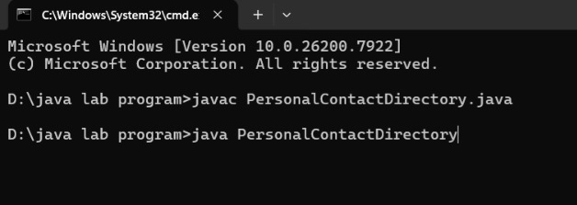
INPUT SCREEN:
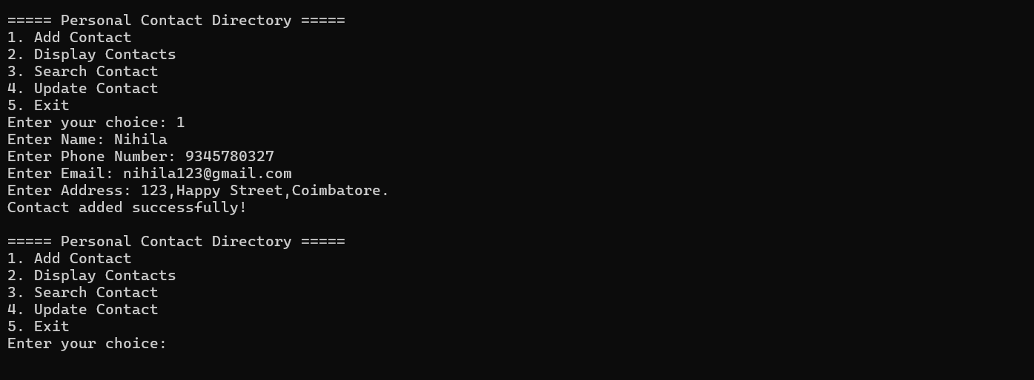

OUTPUT SCREEN:
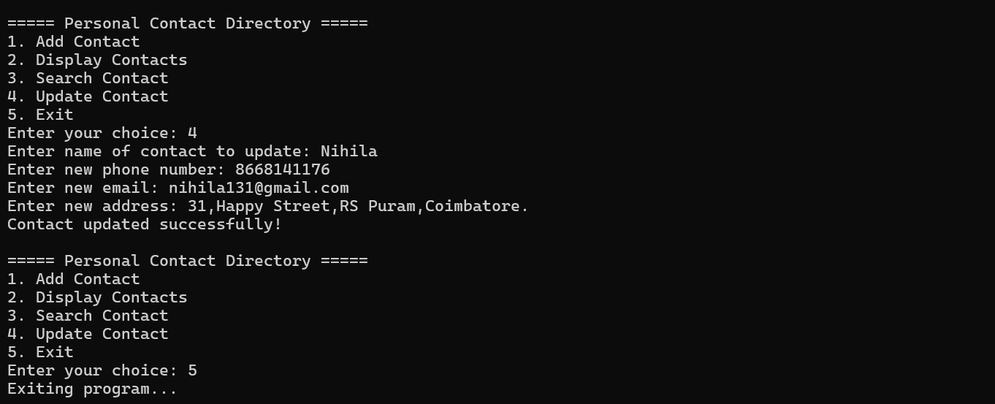
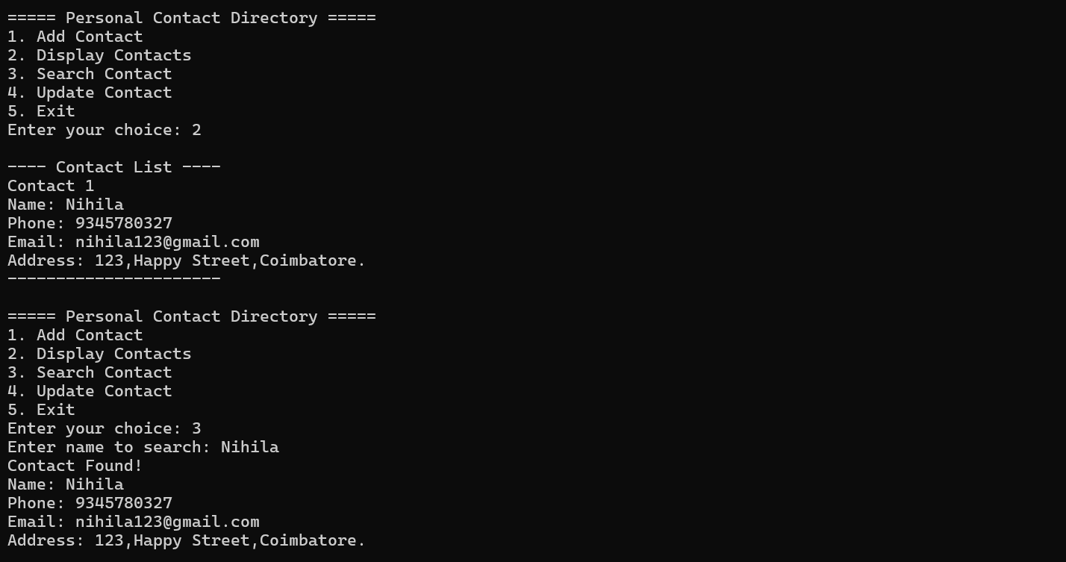

7.DISCUSSION&CONCLUSION

7.1 Discussion
The Personal Contact Directory System was developed to provide a simple solution for managing personal contact details.
The system allows users to store, search, update, and display contact information efficiently. Core Java programming concepts were used during development.
The system was tested with different inputs to ensure that it performs the required operations correctly.
The results show that the system simplifies the process of contact management.

7.2 Conclusion
The Personal Contact Directory with Search and Update Features successfully demonstrates the use of Java programming for developing a practical contact management application.
The system helps users store and manage contact information easily while reducing the effort required to search and update contacts manually.
The project also helps students understand how Java programming can be used to create simple real-world applications.
Future improvements can include:
• Database connectivity
• Graphical user interface
• Contact import/export features

8.REFERENCES
Books
• Herbert Schildt – Java: The Complete Reference
Websites
1. https://www.oracle.com/java⁠
2. https://www.geeksforgeeks.org
3. https://www.w3schools.com⁠
4. https://www.javatpoint.com

